

Department of Computer Science
Course Code: CNS-301
Course Title: Computer Networks
FALL 2024
PROJECT: UNIVERSITY NETWORK USING CISCO PACKET TRACER

GROUP MEMBERS:

M.ALI (22FA-035-CS)

ABDUR RAFAY (22FA-022-CS)

S. ABDUL BASIT (22FA-057-CS)

\

Basically, we are following the given below question step by step.
COMSATS University is a large university which has 4 main buildings situated apart. The university’s students and staff are distributed in 4 departments: these includes the Department of Electrical and Computer Engineering, Department of Mathematics, Department of Computer Sciences, & Admission Office.
Each member of staff has a PC and students have access to PCs in the labs.
Requirements
- Create a network topology with the main components to support the following:
  - Building A: Department of Electrical and Computer Engineering is distributed in the building offices for the faculty, and labs. It is expected that they will share networking equipment (Hint: use of VLANs is expected here)
  - Building B: Department of Mathematics including offices, lecture halls/lecture rooms.
  - Building C: Admission office distributed in different offices.
  - There is also an email server hosted externally on the cloud.
  - Building D: Department of Computer Sciences (CS) this can acts as a smaller campus as well as. It includes different offices and labs.
- You will be expected to configure the core devices and few end devices to provide end-to-end connectivity and access to the internal servers and the external server.
  - Each department/faculty is expected to be on its own separate IP network
  - The switches should be configured with appropriate VLANs and security settings
  - RIPv2 will be used to provide routing for the routers in the internal network and static routing for the external server.
  - The devices in building A will be expected to acquire dynamic IP addresses from a router-based DHCP server

Block Diagram
Let us look at the detail block diagram in Figure 3.1, which illustrates the main components involved in University Network using Cisco Packet Tracer. In this diagram, we have used:
- 2911 Router, for the main campus network
- 3650-24PS Multi Layer Switch, for different departments in the buildings
- 2960-24TT Switches, for each department
- A cloud router,
- Servers, email server hosted externally on cloud, and a web server for IT department
- Host Devices, a PC and a printer
- Wire, Serial DCE (HWIC-2T) for routers connections, Copper cross over for switches connections, and Copper straight through for the host devices connections.
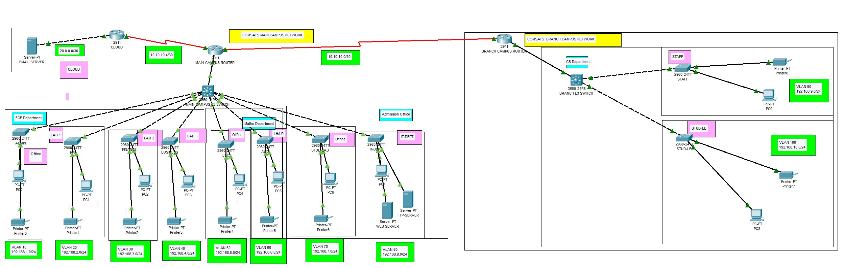
Figure 3.1: Block Diagram of University Network

System Model
A large campus with groups of buildings can also use WAN technology to connect the buildings as shown in the Fig. 3.3. Although the wiring and protocols of a campus might be based on WAN technology, they do not share the WAN constraint of the high cost of bandwidth. After the wire is installed, bandwidth is inexpensive because the company owns the wires and there is no recurring cost to a service provider. However, upgrading the physical wiring can be expensive.
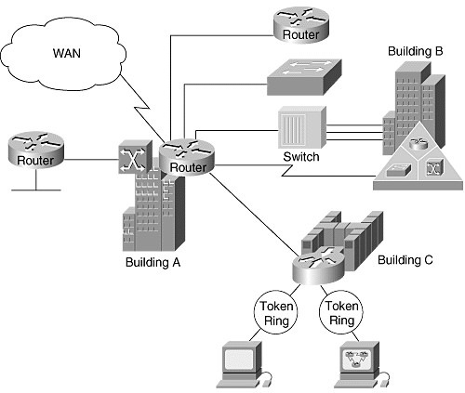
Figure 3.3: System Model of University Network

Simulation and Results

Simulation Results
As discussed in the previous chapter in the section of software selection, we have used Cisco Packet Tracer to simulate our project.

Logical Topology
In the Fig. 4.1 a main branch topology is shown which contain three departments, Electrical and Computer Engineering Department, Mathematics Department, Admission Department, and a Cloud Server.
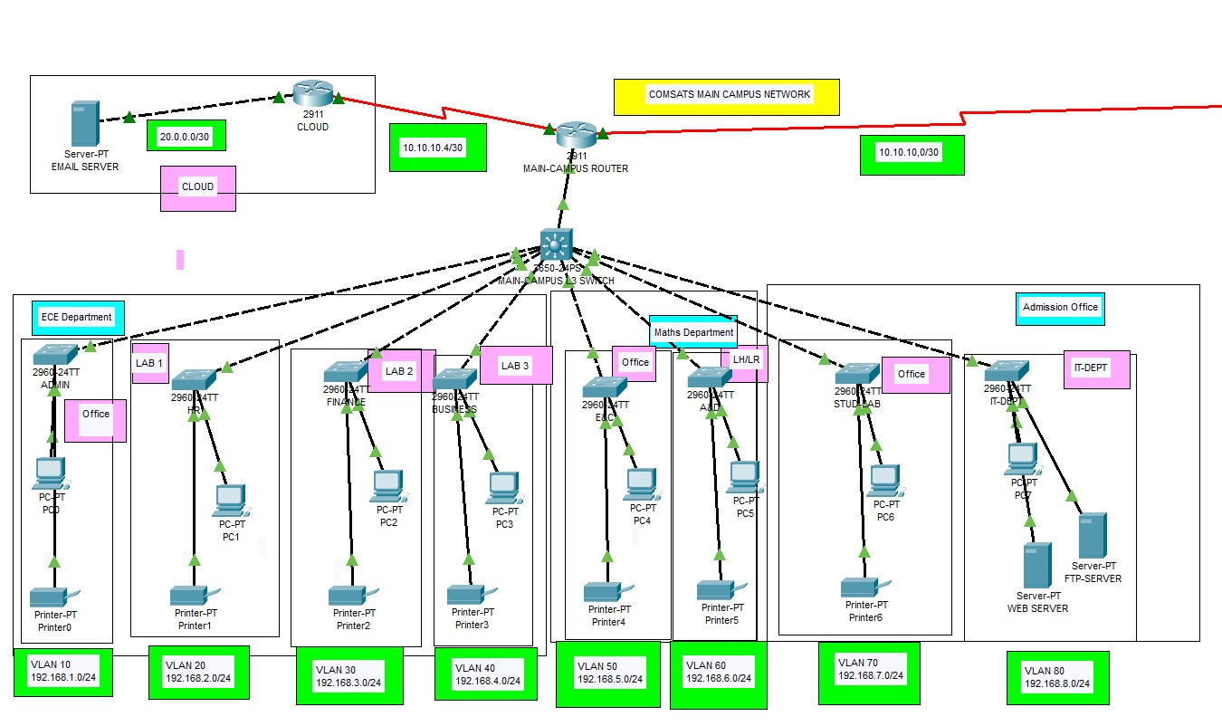
Main Branch Topology
Whereas in, department of Computer Science is shown which contains different offices and lab. The reason we called this COMSATS Branch Campus is because it is quite apart from the other department in this case, we can consider this as a Branch Campus. We can include this in the main branch too but the reason of treating this as a campus is to learn how to connect campus network with the main network.
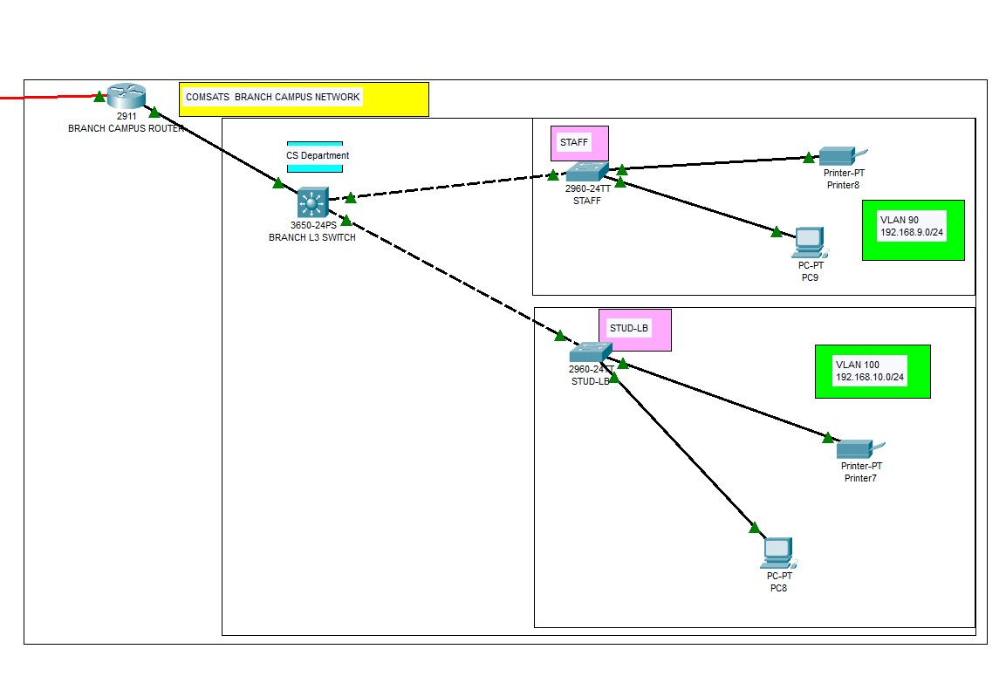
: Branch Topology of CS Department

Using Command Prompt
The ping command is a very common method for troubleshooting the accessibility of devices. It uses a series of Internet Control Message Protocol (ICMP) Echo messages to determine:
- Whether a remote host is active or inactive.
- The round-trip delay in communicating with the host.
- Packet loss.
The ping command first sends an echo request packet to an address, then waits for a reply. The ping is successful only if:
- the echo request gets to the destination, and
- the destination is able to get an echo reply back to the source within a predetermined time called a timeout. The default value of this timeout is two seconds on Cisco routers.
shows a different way to check if our network connectivity is reliable. We have used command prompt of PC2 and have ping two hosts: one from the branch/CS Department host i.e, PC8 with IP address 192.168.10.2/24 and second from Admission Department host’s i.e., PC6 with IP address 192.168.7.2/24.
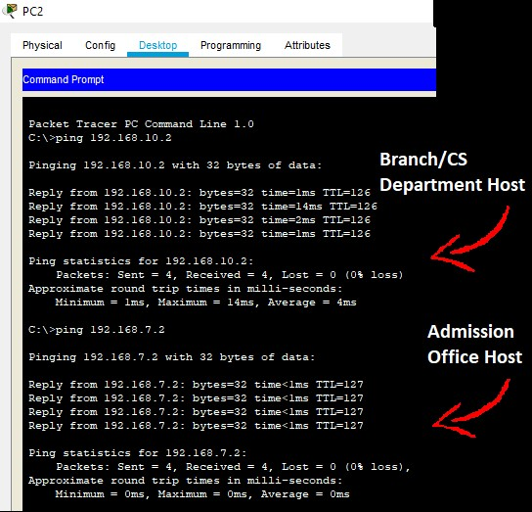
Command Prompt Results

Conclusion
This work describes the COMSATS University Islamabad, Attock Campus Network. We have:
- Successfully simulated our topology using Cisco Packet Tracer.
- Learned basic knowledge of how department communicate with each other in any organization.
- Discussed a real-life university scenario.
In this project, we have done following tasks:
- Planned, designed, and prototyped the network topology for our university i.e., COMSATS University Islambad, Attock Campus.
- Configured the network in Cisco Packet Tracer with appropriate settings to acheive the connectivity and functionalities.

